TASK 5 MAVEN CREATION

**Step 1: Folder Creation**

Create a folder named maven and install git in that folder.

**Step 2: Installing Java**

Clone the repository inside the folder and install java openjdk-17-jdk -y

**Step 3: Maven test**

Test the maven and check any errors present

**Step 4: Maven Clean**

Clean the maven and remove the unwanted items

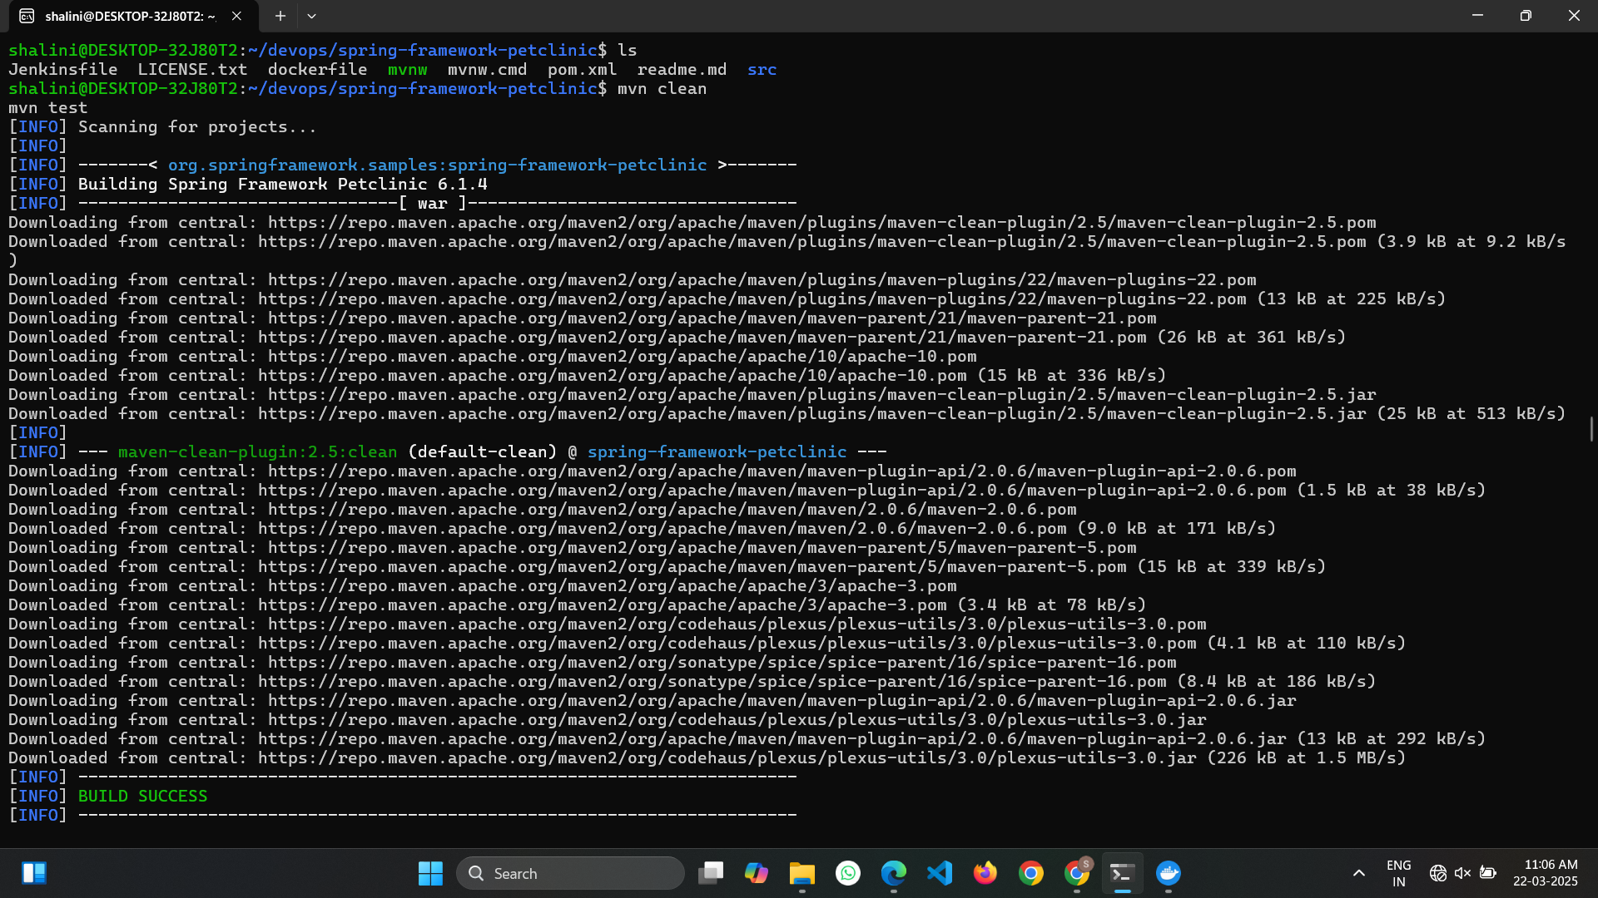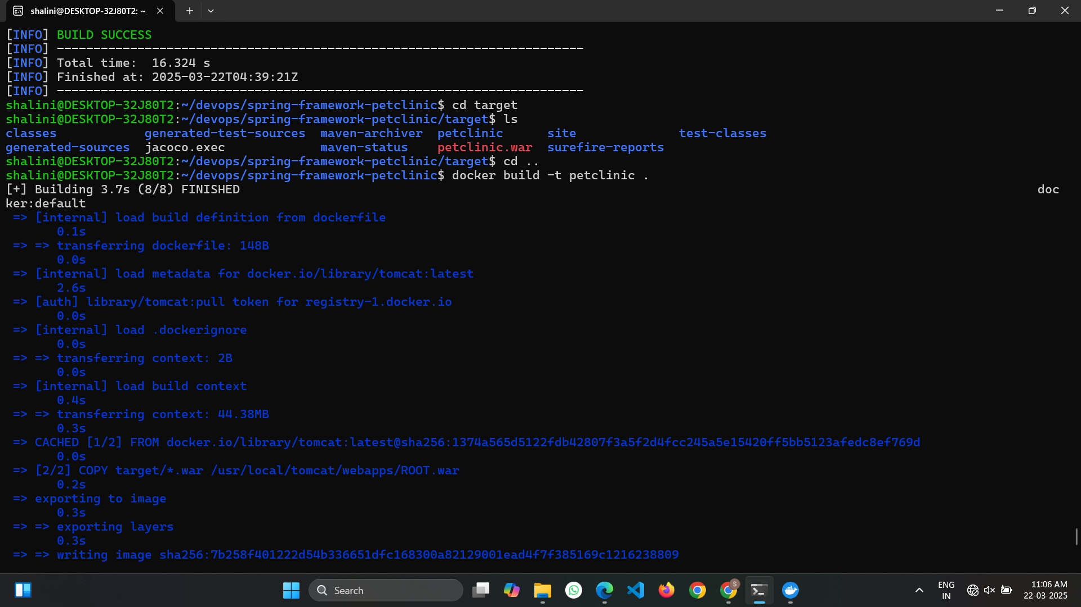

**Step 5:Login in Docker**

Login into docker using the username and password of the docker hub.

**Step 6: Push in Docker**

Push the image inside the docker hub

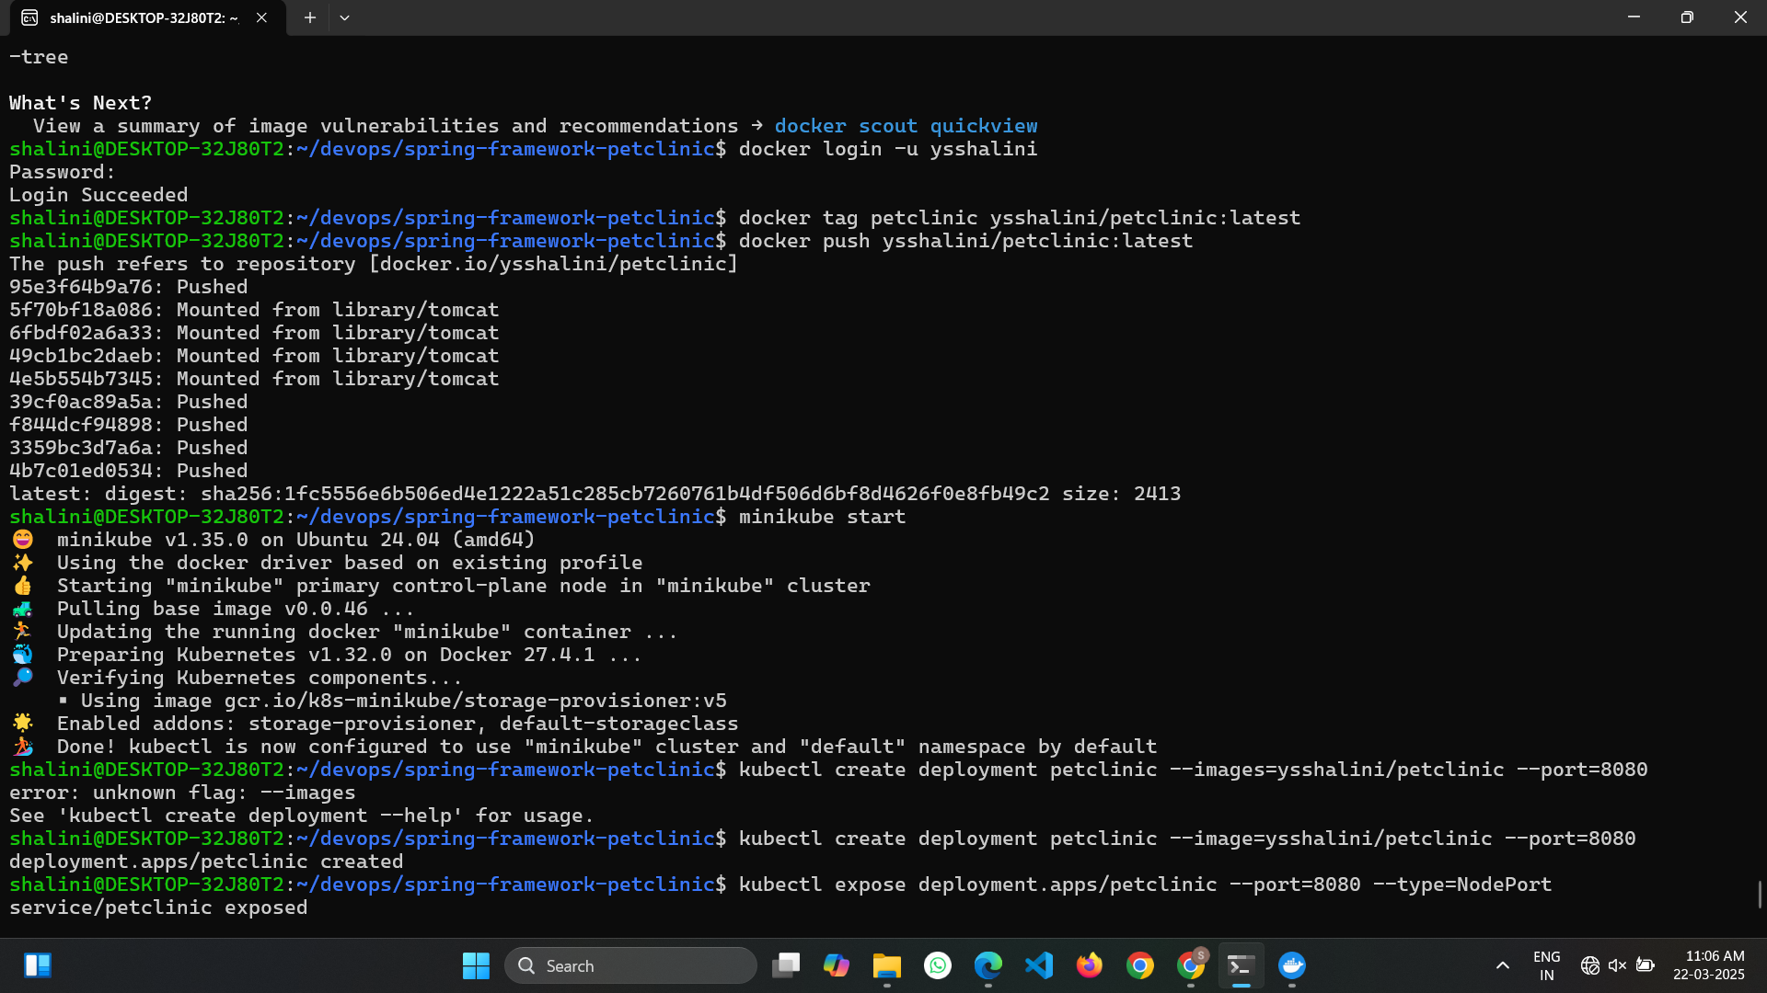

**Step 7: Minikube**

Start the minikube using minikube start

**Step 8: Deployment**

Create the deployment and expose it .Once it is exposed use minikube service to find the url of the webpage. Copy the url. 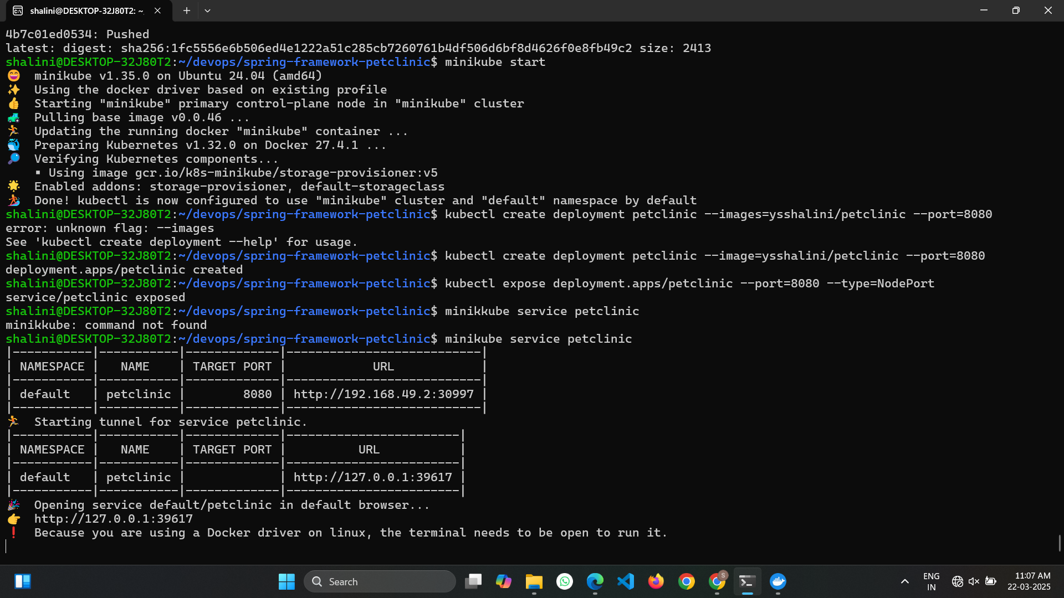

**Step 6: Output**

Paste the url link in the browser and the output will be displayed. 